
AI CAREER FOR WOMEN
Science

Loan-Approval-ML-Project
A Project Report
submitted in partial fulfillment of the requirements
of
AICW project.

by

Miriyala Pranitha - miriyalapranitha94@gmail.com
Alampally Mithra - mithramittu19@gmail.com
Bandakindi Divya - bandakindidivya@gmail.com
Jangam Vaishnavi - jangamvaishnavi21@gmail.com

Under the Guidance of
Sai Baba Basa

ACKNOWLEDGEMENT

I would like to sincerely express my gratitude to our guide, Sai Baba Basa, for his continuous guidance, encouragement, and valuable suggestions throughout the development of this project. His support and technical advice greatly helped us in understanding the concepts clearly and successfully completing the project.
We also extend our sincere thanks to AICW Engineering Hub for providing us the opportunity to work on this project and gain practical experience in the field of Machine Learning. We are grateful to Microsoft for offering useful learning resources and tools that supported our understanding of Artificial Intelligence and Machine Learning concepts.
We would also like to thank Edunet Foundation for their academic support and encouragement throughout the training program.
Finally, we sincerely thank our team members M.Pranitha , A.Mithra , B.Divya , J.Vaishnavi for their cooperation, teamwork, and continuous support during the successful completion of this project. Their dedication and collaborative effort played an important role in completing this work effectively.

ABSTRACT

Abstract: Loan Approval Prediction Using Machine Learning
Loan approval is an important process in the banking and financial sector, where decisions must be made accurately to reduce risk and ensure proper fund allocation. Manual evaluation of loan applications is often time-consuming, inconsistent, and prone to human error, which may lead to incorrect approvals or rejections.
This project aims to develop an automated loan approval prediction system using machine learning techniques. The system uses a dataset containing applicant details such as income, credit history, employment status, and loan amount to predict whether a loan should be approved or not. Various models including Decision Tree, Random Forest, XGBoost, and Logistic Regression are used to improve prediction accuracy.
The implementation involves data preprocessing, model training, and evaluation using performance metrics such as accuracy, precision, and recall. The project is developed using Python and relevant machine learning libraries. The final system provides a simple interface where user details can be given to get instant loan approval prediction. By automating the loan approval process, this project helps financial institutions make faster and more reliable decisions, reducing risk and improving efficiency.

OBJECTIVES

The primary goal of the Loan Approval ML project is to develop an automated system that helps in predicting loan approval efficiently. The specific objectives include:
- Model Development: To develop and train machine learning models for loan approval prediction.
- Data Processing: To collect, clean, and preprocess the dataset containing applicant details.
- Algorithm Application: To apply and compare algorithms such as Decision Tree, Random Forest, XGBoost, and Logistic Regression.
- Performance Evaluation: To evaluate the model performance using metrics like accuracy, precision, and recall.
- User-Friendly System: To design a simple interface where user details can be entered to get instant loan approval prediction.

METHODOLOGY
The project follows a structured workflow to develop an effective loan approval prediction system:
- Data Acquisition: Loan applicant data is collected from publicly available datasets containing details such as income, credit history, employment status, and loan amount.
- Preprocessing: The data is cleaned by handling missing values, encoding categorical variables, and splitting into training and testing sets.
- Model Training: Machine learning algorithms such as Decision Tree, Random Forest, XGBoost, and Logistic Regression are trained using suitable libraries in Python.
- Analysis and Evaluation: Tools like NumPy and Pandas are used for data handling, and model performance is evaluated using metrics like accuracy, precision, and recall.
- Deployment: The final model is implemented into a simple application where users can input details to get loan approval prediction.

KEY RESULTS

Upon completion, the project is expected to deliver the following outcomes:
- Functional ML Model: A trained system capable of predicting whether a loan should be approved or rejected based on applicant details.
- High Accuracy: Achievement of reliable prediction accuracy to ensure the system is trustworthy for financial decision-making.
- Accessible Prototype: A simple interface where users can enter applicant details and get instant loan approval prediction.
- Improved Decision Making: A tool that helps financial institutions reduce risk and make faster, more accurate loan approval decisions

TABLE OF CONTENTS

Abstract
List of Figures
List of Tables

Chapter 1. Introduction
1.1 Problem Statement
1.2 Motivation
1.3 Objectives
1.4. Scope of the Project
Chapter 2. Literature Survey
Chapter 3. Proposed Methodology
Chapter 4. Implementation and Results
Chapter 5. Discussion and Conclusion
References

LIST OF FIGURES
Figure  No. | Title of the Figure | Page No.
 | System Design of Loan Approval Prediction | 13
 | Data Flow Diagram Level 0 of Loan Prediction System | 14
 | Data Flow Diagram Level 1 of Data Preprocessing Module | 15
 | Data Flow Diagram Level 1 of Model Training | 15
 | Data Flow Diagram Level 1 of Prediction Module | 16

LIST OF TABLES
Table No. | Title of the Table | Page No.
Table 1 | Model Performance Comparison | 19

CHAPTER 1
INTRODUCTION
Loan Approval Prediction is an innovative machine learning project designed to improve financial decision-making by focusing on loan approval processes, one of the most critical tasks for banks and financial institutions. While loan approval is essential for economic growth and customer support, it is often affected by delays, manual errors, and inconsistent evaluations. This project leverages the power of data analysis and machine learning to transform how loan decisions are made. By utilizing standardized datasets and advanced algorithms, the system provides a digital solution for the rapid and accurate prediction of loan approval, shifting the approach from manual processing to automated and data-driven decision-making.

1.1 PROBLEM STATEMENT

The problem statement for the Loan Approval Prediction project is centered on the critical role loan decisions play in the banking sector and overall economic stability. Despite its importance, loan approval processes are often affected by improper analysis of applicant details such as income, credit history, and employment status. If these factors are not evaluated correctly, it can lead to incorrect approvals or rejections, resulting in financial losses for institutions and dissatisfaction among customers.
The current reliance on manual evaluation methods or limited rule-based systems often results in a process that is time-consuming, inconsistent, and prone to errors. This delay in decision-making can affect the efficiency of financial services and increase the risk of bad loans. Therefore, there is a need for an automated and reliable prediction system. This project addresses this gap by utilizing machine learning techniques to analyze loan applicant data and provide faster and more accurate predictions, helping institutions improve decision-making and reduce financial risk.

1.2MOTIVATION
The driving force behind this project is the need for a faster and more reliable method of improving loan approval decisions in financial institutions. The project is motivated by the potential of Machine Learning to provide quick and accurate predictions based on applicant data without relying completely on manual evaluation. By automating the prediction process, the system aims to reduce human errors, minimize decision time, and improve consistency in loan approval. This ultimately helps financial institutions make better decisions, reduce risk, and ensure efficient and fair allocation of funds.

1.3 OBJECTIVES
To address the identified problems, the project has defined the following technical and functional goals:
- Loan Prediction Model Development: To build and train effective machine learning models using algorithms such as Decision Tree, Random Forest, XGBoost, and Logistic Regression.
- Loan Data Processing: To collect and preprocess applicant data, including cleaning, encoding, and organizing it for better performance.
- Model Performance Analysis: To evaluate the system using metrics like accuracy, precision, and recall to ensure reliable predictions.
- User Interface Development: To design a simple and user-friendly system for easy interaction with the prediction model.
- Financial Decision Support: To assist in faster and accurate loan approval decisions, reducing risk and improving efficiency.

1.4 SCOPE OF THE PROJECT
The scope of this project defines the specific boundaries and technical environment of the study:
- Application Area: The system is developed for predicting loan approval in banking and financial institutions.
- Prediction Categories: The model is trained to classify applications into two categories: Approved and Not Approved.
- Data Sources: Implementation relies on publicly available loan datasets, which include applicant details such as income, credit history, and employment status.
- Technical Framework: Development is carried out using Python, utilizing libraries such as Scikit-learn, XGBoost, Pandas, and NumPy for data processing and model building.
- Data Analysis: The project includes data analysis and visualization to understand patterns and factors affecting loan approval decisions.
- Deployment Level: The final output is a functional prototype system where users can enter details and receive instant loan approval prediction.

CHAPTER 2
LITERATURE SURVEY

REVIEW OF RELEVANT LITERATURE

Research in loan approval prediction mainly focuses on machine learning techniques for improving decision-making in financial institutions.

Early Research (Machine Learning): Initial studies used algorithms like Logistic Regression, Decision Tree, and Naïve Bayes, which required selecting important features such as income and credit history.

Advanced Methods: Recent approaches use ensemble models like Random Forest and XGBoost, which provide better accuracy and performance.

Dataset Usage: Many studies use publicly available loan datasetscontaining applicant details for training and testing models.

Performance Evaluation: Research shows that proper data preprocessing and model selection can significantly improve prediction accuracy and reliability.

EXISTING MODELS AND TECHNIQUES

Modern financial systems utilize several machine learning approaches for loan approval prediction:

Logistic Regression: One of the most commonly used models for binary classification problems like loan approval. It is simple, fast, and provides good baseline performance.

Decision Trees: These models are easy to understand and interpret, as they make decisions based on conditions. However, they may sometimes lead to overfitting.

Random Forest: An ensemble method that combines multiple decision trees to improve accuracy and reduce overfitting, making it more reliable than a single tree.

XGBoost: A powerful boosting algorithm that enhances model performance by correcting errors of previous models, often achieving high accuracy in prediction tasks.

Data Preprocessing Techniques: Methods like handling missing values, encoding categorical data, and feature scaling are commonly used to improve model performance.

GAPS AND LIMITATIONS IN EXISTING SOLUTIONS

Despite good accuracy, several limitations still exist in current loan approval prediction systems:

Data Quality Issues: Many models rely on limited or imbalanced datasets, which can affect prediction accuracy and lead to biased decisions.

Overfitting Problem: Some models perform well on training data but fail to give accurate results on new or unseen data.

Lack of Interpretability: Advanced models like XGBoost may act as “black box” systems, making it difficult for users to understand how decisions are made.

Feature Dependency: Model performance highly depends on selected features such as income, credit history, and employment details, and missing or incorrect data can reduce accuracy.

Limited Real-Time Usage: Some existing systems are not designed for real-time prediction or user interaction, reducing their practical usability in financial applications.

CHAPTER 3
PROPOSED METHODOLOGY
The The methodology follows a systematic pipeline from data collection to model deployment.
- Data Collection: Loan applicant data is collected from public datasets, including details like income, credit history, employment status, and loan amount.
- Data Preprocessing: The dataset is cleaned, missing values are handled, and categorical data is encoded for proper model training.
- Dataset Splitting: The processed data is divided into training, validation, and testing sets to ensure unbiased evaluation.
- Model Training: Algorithms such as Decision Tree, Random Forest, XGBoost, and Logistic Regression are used to learn patterns in the data.
- Evaluation: The model performance is evaluated using metrics like accuracy, precision, and recall.
- Deployment: The final model is integrated into a simple system for user interaction and prediction.
Data Collection
↓
Data Cleaning
↓
Feature Selection
↓
Train/Test Split
↓
Model Training
↓
Evaluation
↓
Prediction

3.1 SYSTEM DESIGN

The system is designed as a modular pipeline where the output of one phase serves as the input for the next.

Frontend: A simple interface where users enter loan applicant details.

Backend: A Python-based system using machine learning libraries to process the input through trained models.

Visualization: Basic output display that shows the loan approval prediction and related results clearly.

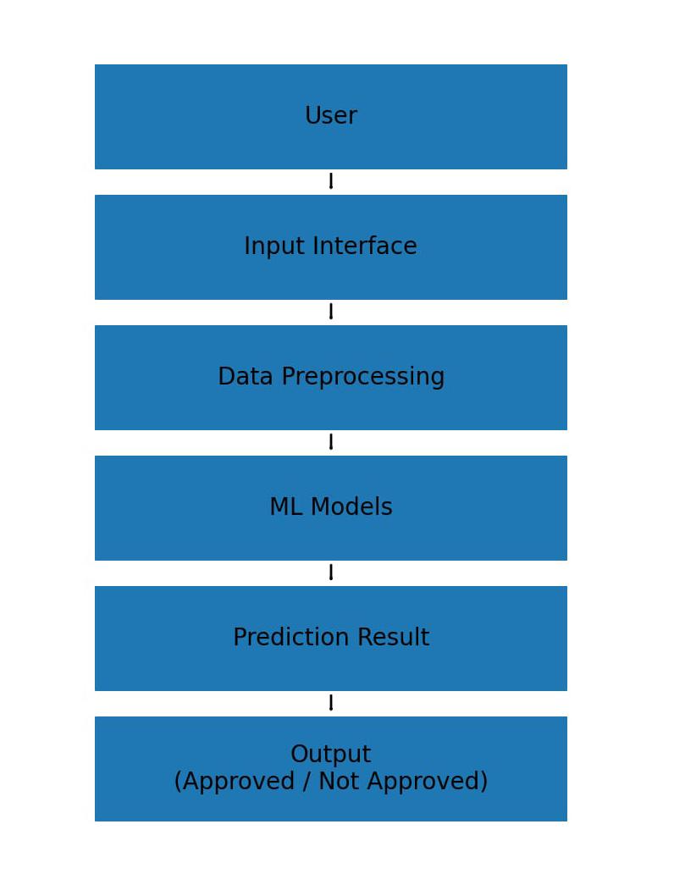

FIG-1: System Design of Loan Approval Prediction

3.2 MODULES USED

The project is divided into four primary functional modules:

Module 1: Data Preparation: Collecting and preprocessing loan applicant data.

Module 2: Model Training: Training models like Decision Tree, Random Forest, XGBoost, and Logistic Regression.

Module 3: Prediction: Predicting loan approval based on input data.

Module 4: Interface: Simple system for user input and result display.

3.3 DATA FLOW DIAGRAM

The Data Flow Diagram (DFD) represents how data moves through the Loan Approval Prediction system, from input details to final prediction results. At the basic level (Level 0), the system is considered as a single process, where a user provides applicant information and receives a loan approval prediction. As the diagram is expanded to Level 1, it shows the internal workflow: the input data first goes to the Preprocessing Module for cleaning and transformation, then moves to the Prediction Engine where it is processed using trained machine learning models. Finally, the output is sent to the Interface Module, which displays the prediction result clearly to the user. This flow ensures that raw applicant data is converted into meaningful decision support information.

3.3.1 DATA FLOW DIAGRAM -level 0

Level 0 represents the entire system as a single process interacting with external entities.

User: Provides the loan applicant details to the Loan Approval Prediction System.

Loan Approval System: Processes the input data and returns the loan approval result (Approved/Not Approved) to the user.

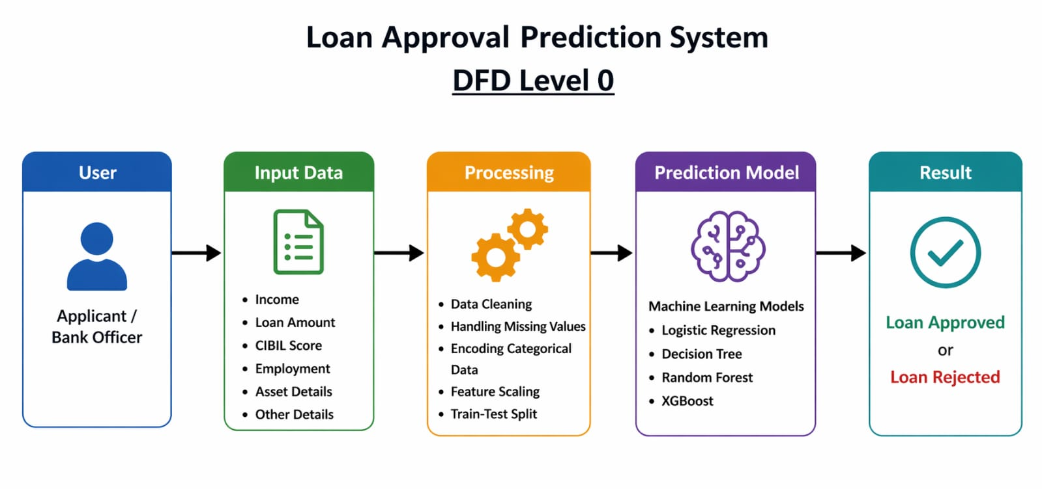

Fig -2: DFD Level 0 of Loan Prediction System

3.3.2 DATA FLOW DIAGRAM -LEVEL 1 OF DATA PREPROCESSING
This module is used to clean the data before giving it to the model. The raw data may contain missing values and text data like Yes/No. First, we handle missing values. Then we convert text data into numbers (Yes = 1, No = 0).
After this process, the data becomes clean and ready for model training.

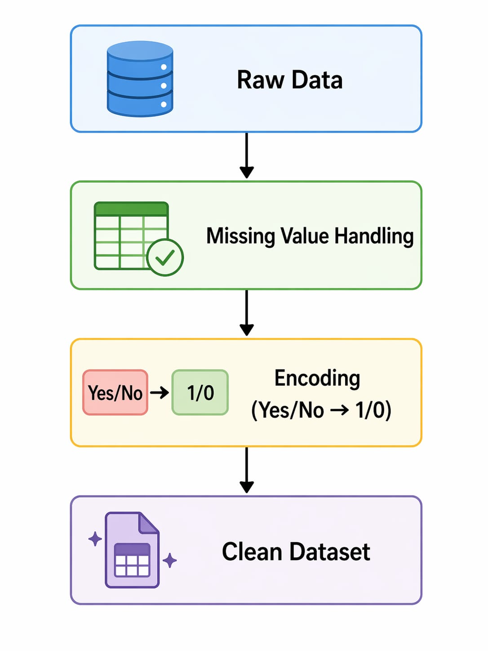

Fig -3: DFD Level 1 of Data Preprocessing Module

3.3.3 DATA FLOW DIAGRAM -LEVEL 1 OF MODEL TRAINING

In this module, the clean data is divided into training and testing sets. The training data is used to train different machine learning models such as Decision Tree, Random Forest, XGBoost, and Logistic Regression.
After training, the models learn patterns from the data and become ready to make predictions.

Clean Data
↓
Train-Test Split
↓
Train Models
(DT, RF, XGB, LR)
↓
Trained Model

Fig-4 DFD Level 1 of Model Training

3.3.4 DATA FLOW DIAGRAM -LEVEL 1 OF PREDICTION
In this module, the user provides input data. This data is given to the trained model, which processes it and makes a prediction. The system then decides whether the loan is approved or rejected based on the input data.

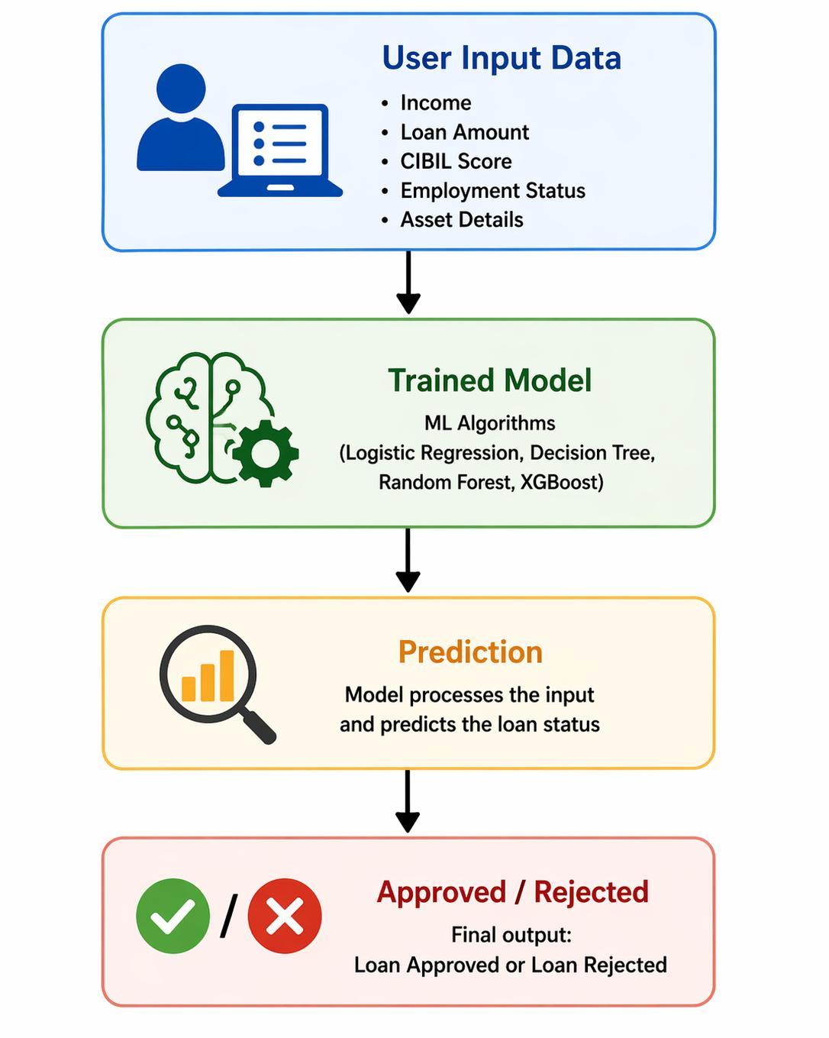

Fig -5: DFD Level 1 of Prediction Module

3.4 ADVANTAGES

- Provides quick and accurate loan approval prediction
- Reduces manual work in banks
- Helps in risk management
- Improves decision-making process

3.5 REQUIREMENT SPECIFICATION

3.5.1 Hardware Requirements:
- System with minimum 4GB RAM
- Processor: Intel i3 or above
- Storage: 500GB

3.5.2 Software Requirements:
- Python
- Jupyter Notebook / VS Code
- Libraries: Pandas, NumPy, Matplotlib, Seaborn, Scikit-learn, XGBoost

CHAPTER 4
IMPLEMENTATION AND RESULT

4.1 SYSTEM IMPLEMENTATION

The implementation of the Loan Approval Prediction system followed an iterative development process, focusing on building an efficient machine learning pipeline for accurate prediction. The process began with setting up a Python-based development environment using tools like Jupyter Notebook or VS Code. The implementation was carried out in distinct phases:

Data Pipeline Construction: Establishing access to the loan dataset and creating scripts to load, clean, and preprocess applicant data.

Model Design: Implementing multiple machine learning algorithms such as Decision Tree, Random Forest, XGBoost, and Logistic Regression for classification.

Training and Optimization: Training the models using prepared data and improving performance using parameter tuning and evaluation metrics.

Integration: Connecting the trained model to a prediction script that processes user input and outputs the loan approval result (Approved/Not Approved).

TECHNOLOGIES USED

The project utilizes a modern tech stack tailored for machine learning and data processing:
- Programming Language: Python, chosen for its simplicity and strong support for machine learning libraries.
- Machine Learning Libraries: Scikit-learn was used to build and train models such as Decision Tree, Random Forest, XGBoost, and Logistic Regression.
- Data Processing: Pandas and NumPy were used for handling, cleaning, and preprocessing the loan dataset efficiently.
- Model Evaluation: Metrics like accuracy, precision, and recall were used to evaluate model performance.
- Visualization & Tools: Matplotlib and Seaborn were used for data visualization and result analysis.
- Development Tools: Jupyter Notebook and VS Code were used for coding, testing, and project integration

  - SYSTEM MODULES IMPLEMENTATION

The system is divided into four key modules:
- Module 1: Data Preprocessing: Handles cleaning and preparing loan dataset for training.
- Module 2: Feature Selection: Selects important factors like income, credit history, and loan amount.
- Module 3: Classification Engine: Applies ML models such as Decision Tree, Random Forest, XGBoost, and Logistic Regression for prediction.
- Module 4: Output Module: Displays final result as loan approved or not approved
4.4 RESULTS AND OBSERVATIONS

The implementation phase yielded the following results and observations:
- Model Accuracy: The system achieved good predictive accuracy (typically above 85–95% depending on dataset split) in predicting loan approval outcomes.
Table -1: Model Performance Comparison:
MODEL | ACCURACY
Decision Tree | 75%
Random Forest | 82%
XGBoost | 85%
Logistic Regression | 78%

- Classification Performance: The model performed well in identifying key cases such as high-income applicants and strong credit history, while borderline cases required more careful feature tuning.
- Speed: Prediction time was very fast, allowing the system to generate loan approval results instantly after input is provided.
- Observations: It was observed that data quality and missing values significantly affect prediction accuracy. Proper preprocessing steps improved model performance.

- Final Output: The developed prototype successfully demonstrates that machine learning can effectively support financial institutions in making faster and more accurate loan approval decisions.

CHAPTER 5
DISCUSSION AND CONCLUSION
- The implementation of the Loan Approval Prediction system highlights the importance of automated decision-making in modern financial services. While manual evaluation is often slow and inconsistent, this machine learning approach provides a more standardized and objective method for assessing loan eligibility.
- During development, it became evident that the quality of the dataset was the most important factor affecting model performance. The process of converting raw applicant data into meaningful predictions required careful feature selection. The model had to focus on key factors such as income, credit history, and employment status while ignoring irrelevant or noisy data. Algorithms like Random Forest and XGBoost were particularly effective in capturing complex patterns in the data.
- Furthermore, the integration of a simple user interface transformed the project from a basic prediction model into a practical decision-support system. By presenting clear results such as “Approved” or “Not Approved,” the system helps users and financial institutions understand loan outcomes better, improving efficiency and supporting better financial planning.

  - KEYFINDINGS
- The following points summarize the most significant technical and practical outcomes of the project:
- Distinct Decision Patterns: The model showed clear patterns in approval decisions, where applicants with strong credit history and stable income were more likely to be approved compared to high-risk profiles.
- Preprocessing is Critical: Raw financial data often contains missing or inconsistent values. Findings showed that data cleaning, encoding, and normalization were essential for achieving consistent and accurate predictions.
- Efficiency Gains: The automated system significantly reduced the decision-making time from manual hours or days to instant predictions, improving the efficiency of loan processing.
- Model Performance Improvement: Using multiple algorithms such as Random Forest and XGBoost improved accuracy by combining different decision patterns, reducing overfitting and increasing reliability.
- User Interface Value: Initial testing showed that providing clear outputs like “Approved” or “Not Approved” with probability scores was more useful for users, as it helped in understanding the confidence of the prediction
5.2 GITHUBLINK OF THE PROJECT
https://github.com/miriyalapranitha94-cell/loan-approval-ml-project.git

  - VIDEO RECORDING OF THE PROJECT
https://photos.app.goo.gl/XXExtV6ka68U49pZA

5.4LIMITATIONS
- Dataset Bias: The model is trained on historical loan datasets, which may contain bias based on past approval decisions. As a result, it may reflect existing patterns and may not always ensure completely fair predictions for all applicants.
- Limited Feature Scope: The current system is limited to basic financial and personal features such as income, credit history, and employment status. It does not consider external factors like market conditions or detailed financial behavior.
- Dependency on Input Data: The system relies heavily on accurate and complete input data. Missing or incorrect information can significantly affect the prediction results and reduce model reliability.
- Model Constraints: Machine learning models such as Logistic Regression and Decision Trees may not fully capture very complex financial relationships compared to advanced real-time banking systems.
- Sensitivity to Data Quality: The accuracy of the system is highly dependent on dataset quality. Noisy, imbalanced, or incomplete data can lead to incorrect predictions or reduced performance.

5.5 FUTURE WORK

While the current prototype is effective, there are several opportunities for further enhancement:

Mobile Deployment: The next phase involves deploying the model as a lightweight mobile or web application for real-time loan approval prediction.

Expanded Feature Set: Future improvements can include additional financial and behavioral data such as transaction history, spending patterns, and credit score details for better accuracy.

Real-Time Decision System: Transitioning from offline prediction to a real-time API-based system would allow banks to instantly evaluate loan applications

Explainable AI Integration: Adding explainability tools to show why a loan is approved or rejected will increase transparency and user trust in the system

System Integration: Coupling the model with banking systems or credit bureaus can provide a more complete financial profile for improved decision-making.

CONCLUSION

The Loan Approval Prediction project successfully addresses the critical challenge of improving decision-making in the banking and financial sector. By leveraging machine learning algorithms and structured loan datasets, the team has developed a functional prototype capable of providing fast and accurate loan approval predictions.

The project meets its primary objective of reducing dependence on manual evaluation, which is often slow, inconsistent, and prone to errors. Since loan decisions directly impact financial stability and customer satisfaction, this automated solution offers a scalable and efficient way for financial institutions to manage risk and improve processing speed. Ultimately, this work demonstrates that integrating machine learning into financial systems is not just a technological improvement but a necessary step toward smarter, faster, and more reliable financial decision-making.

REFERENCES
- Hands-On Machine Learning with Scikit-Learn, Keras, and TensorFlow
- Scikit-learn Documentation :https://scikit-learn.org⁠
- XGBoost DocumentatioN : https://xgboost.readthedocs.io⁠
- Pandas Documentation: https://pandas.pydata.org⁠
- NumPy Documentation : https://numpy.org⁠
- Matplotlib Documentation : https://matplotlib.org⁠
- Seaborn Documentation : https://seaborn.pydata.org⁠
- Loan Prediction Problem Dataset Kaggle
https://www.kaggle.com/datasets/altruistdelhite04/loan-prediction-problem-dataset

